Solving the vibrational equations using FBR and DVR methods
Problem 1: Try to solve the following Schrödinger equation of one-dimensional harmonic oscillator (in atomic units):
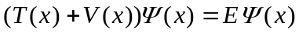 (1)
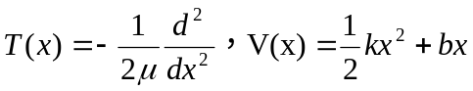 (2)
With k=2000, b=0.05
[Can you find the analytic solution of this equation?]
In fact, this problem is easy to solve. The solutions are:
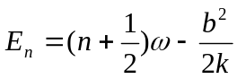 (3)
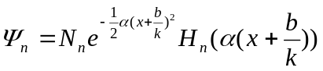 (4)
Where, 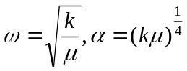 (5)
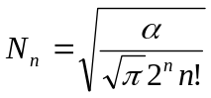 (6)
Exercise 1: Plot the wave functions of the lowest 6 states.
Now, I try to explain you how to use FBR and DVR methods to solve the general one-dimensional Schrödinger equation (eq. 1).
FBR method

FBR: Finite Basis Representation
In quantum chemistry, we have the variational method in which the wave function is expressed by:
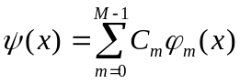 (7)
Where, M is the number of the basis functions, 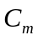is the expansion coefficient,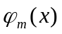 the basis function. Substitute eq. (7) into eq. (1), one obtain the following matrix eigenvalue problem:
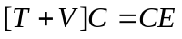 (8)
Where the element of the kinetic matrix is: 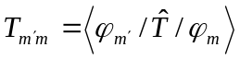 (9)
The elements of the potential matrix is 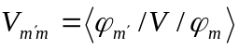 (10)
Usually, we use harmonic oscillator or Morse oscillator wave functions as the basis set. In this case, the kinetic matrix is diagonal and easy to calculate, while the potential matrix is a full matrix and difficult to calculate (although in the simple case of Problem 1, you can find the potential matrix has a simple form). For the purpose of computational efficiency, we often use HEG quardrature [Harris et al, J. Chem. Phys. 43, 1515 (1965)] (which is indeed a type of Gauss quardrature) to calculate the potential matrix. The main steps of this procedure is as follows:
- Choose the basis set: 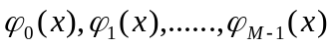
- Calculate the matrix: 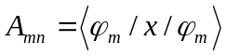 (11)
- Diagonalize the symmetric matrix A to produce the eigenvalue: 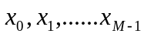 and eigenvector: 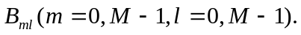
- Any integrals of function of x between the basis set can be then easily calculated:
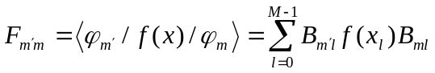 (12)
In the case of potential matrix,
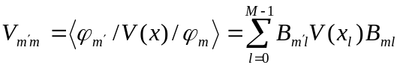 (13)
Once you obtain the kinetic matrix and potential matrix, use a standard diagonalization method such as TQL method to produce the eigenvalue E_{n} and the corresponding wave function:
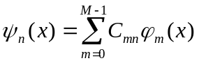 (14)
Exercise 2: Use FBR method to solve Problem 1. The basis functions are:
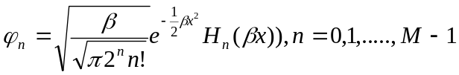. The value of  is not necessary equal to . I suggest you perform the calculation with M=50 and 100, and 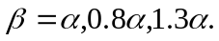 Then compare the results with the exact results obtained from eq. (3) and (4).
DVR method
DVR: Discrete Variable Representation
Because the potential matrix in FBR is a full matrix and computational very time-consuming, some researchers find an alternative way (DVR) to solve the eigenvalue problem. One can rewrite eq. (13) in the matrix form:
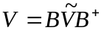 (15)
Where, 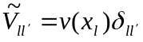. Substitute eq. (15) into eq. (8),
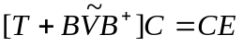 (16)
Multiple the above eq. On the left by 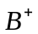, and use the relation 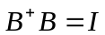, leads to:
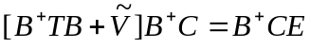 (17)
Set: 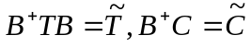, the above eq. becomes:
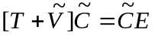 (18)
where,
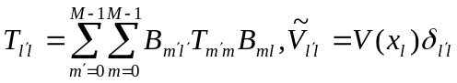 (19)
Compare eq. (18) and (8), you will find:
- the eigenvalue in both DVR and FBR is identical;
- the index of matrix (m,m’) in FBR is the notation of basis function, whereas the index of matrix(l,l’) in DVR is the notation of discretized coordinates;
- the eigenvector from the DVR eigenproblem is related to wave function by:
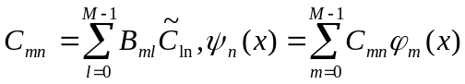 (20)
So you can also see that the DVR points is dependent on the basis set used.
Exercise 3: Use DVR method to solve Problem 1. The basis functions are: . M=50 and 100, and 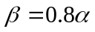. The energies and the wave functions should be identical to the results obtained in Exercise 2 with the same M and .
There are some other basis sets often used in DVR method. For example, Colbert and Miller (J. Chem. Phys. 96, 1982(1992)) suggested a sinc-DVR points. In this approach, 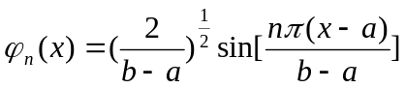 n=1,……M (21)
(a,b) is the integral of the coordinate x of interest. The DVR points is equally spaced:
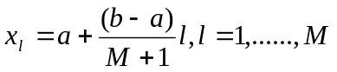 (22)
The DVR of the potential energy is simply as:
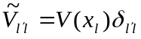 (23)
The DVR of the kinetic energy is given by:
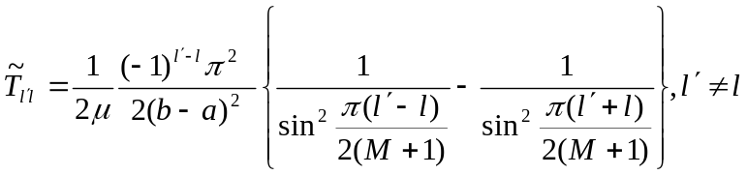 (24)
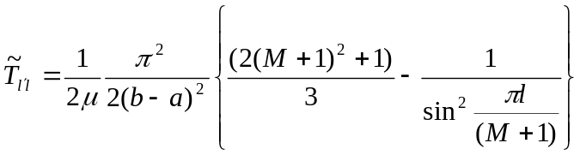 (25)
One can demonstrate that at the DVR points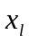, the wave function is simply as:
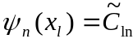 (26)
except a normalization factor.
Exercise 4：Use sinc-DVR method to solve Problem 1. Compare the energies with the previous exercises. Plot the wave function for the lowest states and compare with Exercise 1.
Atomic units
The atomic units are usually in quantum chemical calculations. For convenient, other units are used when read or write. In the atomic units, 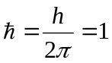,
Mass: 1au=1.0/1822.89 amu
For example, the mass of ¹⁶O=15.994914 amu =29156.96878 au
Length (bohr): 1au = 0.5291771 Å
Energy (hartree): 1au =27.2114 eV = 219474 cm⁻¹ = 2625.50 KJ/mole
Time: 1au = 0.0241890 fs

